SEQUENCES AND SERIES

Sequence: a sequence is an ordered list or an ordered set of numbers. The idea of ordering is important!

Ex: u₁, u₂, u₃, …..

1,3,5,7,….

1, -3, 5, -7, ….

2,4,8,16,….

2, -4, 8, -16, ….

Series: It is often valuable to talk about adding the terms of a sequence. This creates a series.

Ex: u₁+ u₂+ u₃, …..

1+3+5+7+….

1-3+5-7+….

2+4+8+16+….

2-4+8-16+….

Convergence of sequence

Sequence symbol: {u_{n}} = {u₁,u₂,u₃,….,u_{n},….}

A sequence is convergent if it has a limit, and we say the sequence is convergent. Otherwise, the sequence is divergent. Thus if 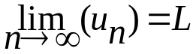 exists and is finite then the sequence is convergent; otherwise it is divergent.

Ex: 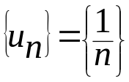, 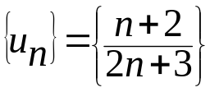, 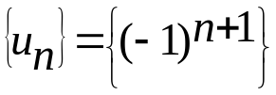

A convergent sequence is bounded. Give example.

A bounded sequence might not be convergent. Give example.

Check the convergence of the following sequences.

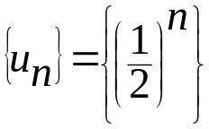

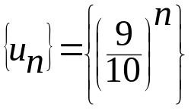

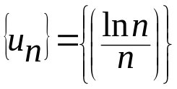

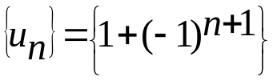

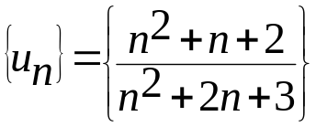

Series

Here after the discussed form of series is the infinite series, i.e. the series with infinite number of terms.

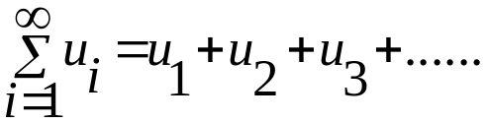

An infinite series is called convergent if its sum exists and finite. Otherwise it is called divergent.

Ex: State whether or not the following series is convergent. If it is convergent, state the sum.

1 – 2/3 + 4/9 – 8/27 + …..

1 – 1 + 1 – 1 + ……

3. 1 + 2 + 3 + 4 + ……

4. 0.54545454…..

=0.54 + 0.0054 + 0.000054 + 0.00000054 + …..

5. 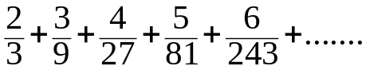

Some special series

Arithmetic series → a + (a+b) + (a+2b) + …..

always divergent, unless a=0 and b=0

Ex: 1 + 3 + 5 + ….. S_{n}= ½n{2a+ (n-1)b} = ∞, since n→∞.

Geometric series → a + ar + ar² + …..

Convergent if – 1 < r < 1.

Otherwise (r≥1 or r≤-1) it is divergent.

S_{n} = 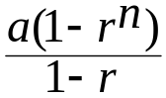. If -1 < r < 1 and n →∞ then r^{n} → 0 and S∞ = 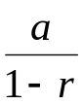

Ex:

1 + 2 + 4 + 8 + …..a=1, r=2 > 1, divergent.

2 – 6 + 18 – 54 + 162 – 486 + …..,a=2, r=-3<-1, divergent.

18 – 9 + 9/2 – 9/4 + 9/8 – 9/16 + …..,a=18, r=-½

-1 < -½ < 1, convergent to S∞ = = 18/(1+1/2)= 12.

Harmonic series

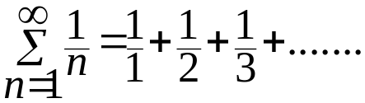

It is divergent.

Hyper-harmonic series

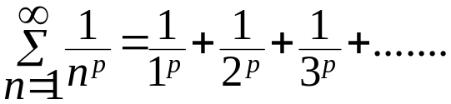

It is convergent if p > 1

It is divergent if p ≤ 1

Ex:

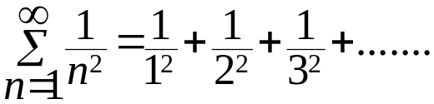,p=2>1, convergent.

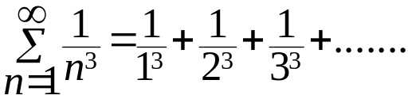,p=3>1, convergent.

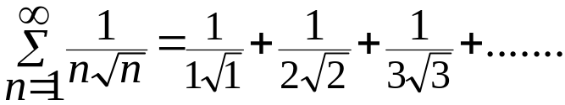, p=1½>1, convergent.

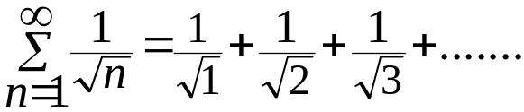, p= ½ < 1, divergent.

Tests for Convergence

If 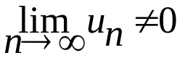 then the series is divergent

If 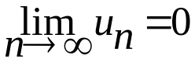 then use one of the following tests

1. Ratio Test (d’Alembert test)

If Σu_{n} is positive series and 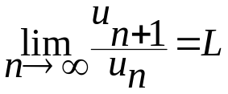 then:

if L < 1 then the series is convergent.

if L = 1 then the test fails.

if L > 1 then the series is divergent.

Ex: 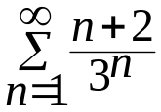, 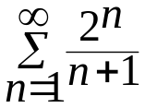, 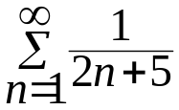

2. Integral Test

If Σu_{n} is positive series and 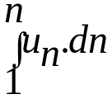 is convergent, then Σu_{n} is convergent.

Ex: 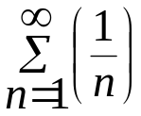,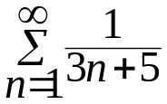, 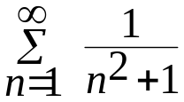

Negative Series

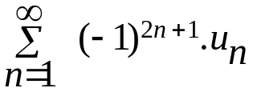 or 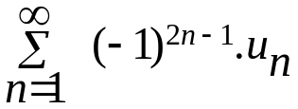

Negative series is treated as minus of positive series.

Ex: 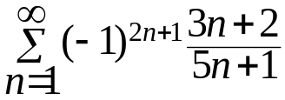
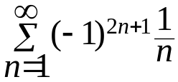
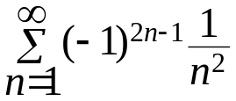
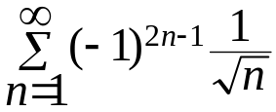

Alternating Series (Deret Ayun)
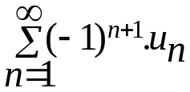 or 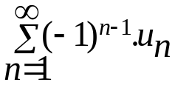 or 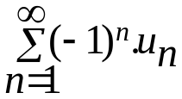
= u₁ – u₂ + u₃ – u₄ + …..
Alternating series is convergent if:
- u₁ > u₂ > u₃ > u₄ > …..
2.
Ex:
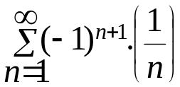, 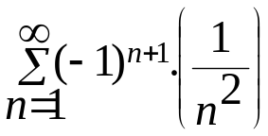, 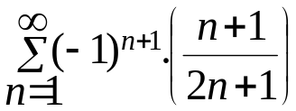

Absolute Convergent and Conditional Convergent
- If 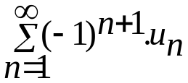 is convergent and 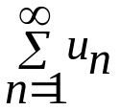convergent then it is absolute convergent.
- If is convergent and divergent then it is conditional convergent.

Ex: 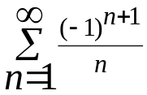, 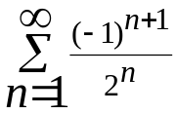

Power Series (Deret Pangkat/Deret Kuasa)
Form: 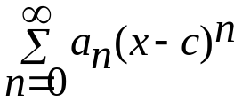is called the power series about x=c.
This series will certainly be convergent for x=c.
The power series will be absolute convergent if 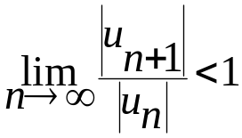 and divergent elsewhere, but you should check the endpoints.
Ex: Find the interval of convergence of:
a. 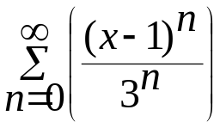 b. 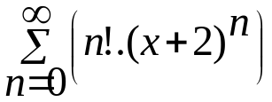
c.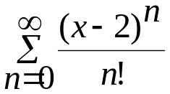 d. 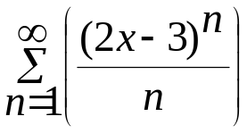

Exercise
Check the convergence of:
- 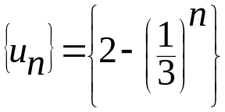
- 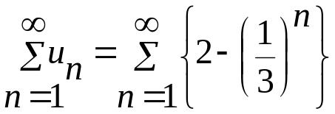
- 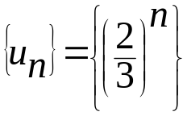
- 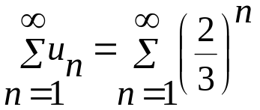
- 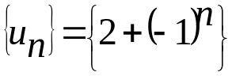
- 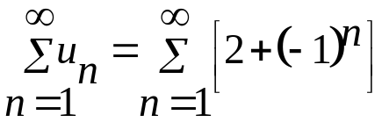
- 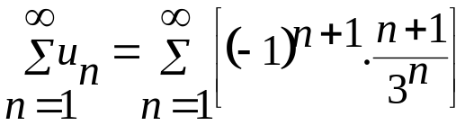
- 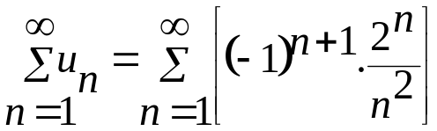

Mac-Laurin’s Series
A function y=f(x) can be written as Mac-Laurin’s series about x=0 if the derivatives of all order exist and are continuous at x=0.
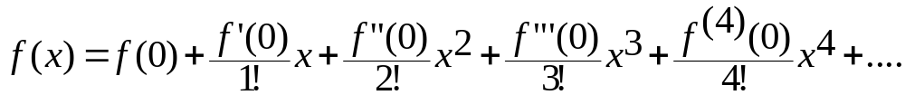
Ex:
- f(x)=e^{x}, f(x)=e^{–x}, f(x)=e^{0.5x}, f(x)=e^{2x}
- f(x)=sin x
- f(x)=cos x
- f(x)=e^{cos x}
- f(x)=ln(1+x)
- f(x)=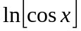 about x=0

Taylor’s Series
Y=f(x) can be written as Taylor’s series about x=a if the derivatives of all order exist and continuous at x=a.

Ex:
- f(x)=e^{x} about x=1
- f(x)=sin x about x=π/2
- f(x)=ln x about x=1

Exercises
- Find the interval of convergence of:
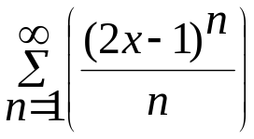
- Find the interval of convergence of:
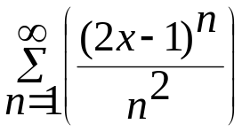
- Find the interval of convergence of:
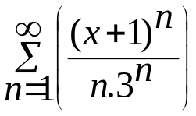
- Find the interval of convergence of:
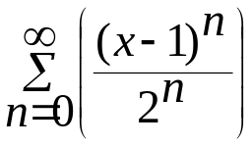
- Find McLaurin’s series for f(x) = ln (cos x) at x=0.
- Find Taylor’s series for f(x) = ln (cos x) at x=^{π}/₃.

- Find the interval of convergence of 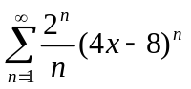
- Find the interval of convergence of 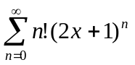
- Find the interval of convergence of 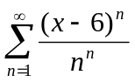 (hint: use root test)
- Find the Mac Laurin series for f(x) = x.cos x (4 non-zero terms only)
- Find the Mac Laurin series for f(x) = arc tan x (2 non-zero terms only)
- Find the Taylor series until the third degree for f(x) = tan x at x = ¼ π. (4 non-zero terms only)

Exercise
- A. Find the critical points of z=f(x,y) = x⁴ + y⁴ – 4xy.
Ans: min (1,1), min (-1,-1), saddle (0,0).

B. Find the absolute max/min of z=f(x,y) = 2 + 2x + 2y – x² – y² on the triangular region in the ﬁrst quadrant bounded by the lines x = 0, y = 0, and y = 9 − x. Ans: the maximum value 4 at (1,1) and the minimum value −61 at the points (0,9) and (9,0).

C. A rectangular box has no top with a volume of 128 cm³. Its height is 4 times its length. Find the dimension of the box that has a minimum surface area.

- Evaluate
- 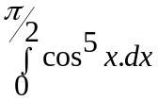
- 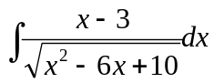
c. 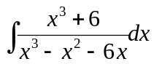
d. 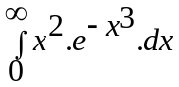
e. 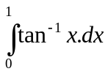

- A region is bounded by y = 4 – x², y = 3x and y axis.
- Draw and find the area
- If the area is rotated about x = 4, find the volume.

- A. Find the arc length of 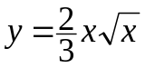 from x=0 to x=1.
B. Find the area of surface of revolution if the arc length in part A is rotated about y axis.

- Find Mac-Laurin series for 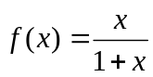

- A. Test the convergence of 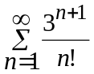

B. Find the interval of convergence of 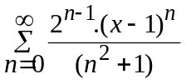
7. A. Is this sequence convergent? 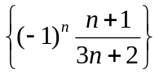
B. Is this series convergent? 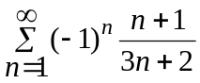
8. A rectangular box has no top with a volume of 32 cm³. Find the dimension of the box that has a minimum surface area. Find the minimum surface area and check that this is really a minimum.

Assignment max 6 students
- Is this sequence convergent? 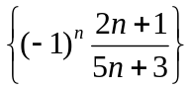
- Is this series convergent? 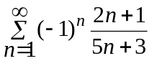
- Test the convergence of 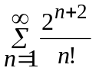
- Find the interval of convergence of 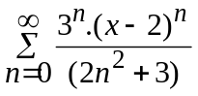
- Find the Mac Laurin series for f(x) = x.sin x (4 non-zero terms only)
- Find Taylor’s series for f(x) = ln (sin x) at x=^{π}/₆.
- Is this series convergent? 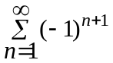
- Prove that 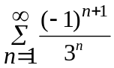 is convergent. What type of convergence is this?

- Find Mc Laurin series for f(x)=ln(2+x)
- Find Taylor series for f(x)=ln(2+x) at x = 1

Check the convergence of the followings (determine convergent or divergent).
- 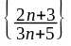
- 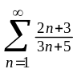
- 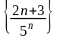
- 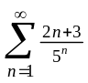
- 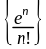
- 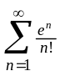
- 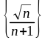
- 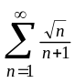
- 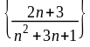
- 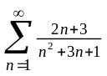
- 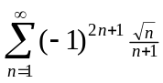
- 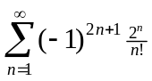
- 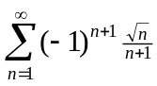
- 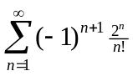
Find the interval of convergence of:
- 
 